Ex.No.2 Implement word count program using MapReduce

Aim
To implement a word count program using MapReduce.

Pre-requisite
- Java Installation - Check whether the Java is installed or not using the following command.
java -version
- Hadoop Installation- Check whether the Hadoop is installed or not using the following command.
hadoop version

Steps to execute MapReduce word count to find out the frequency of each word that exists in a text file.
- Create a text file in your local machine and write some text into it.
$ nano data.txt
- 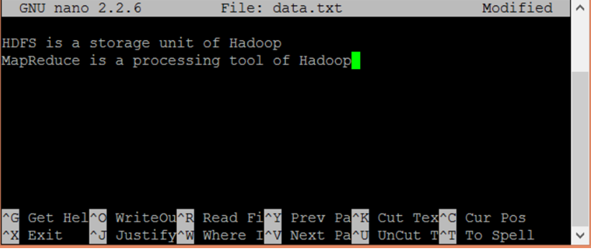

- Check the text written in the data.txt file.
$ cat data.txt

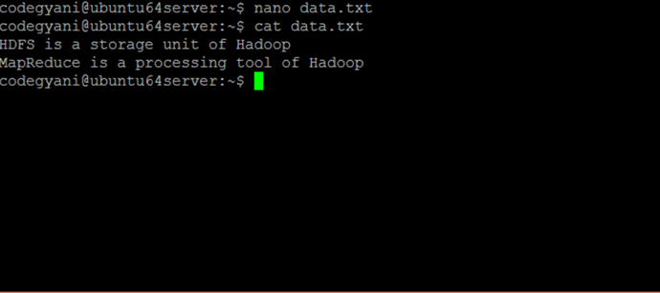
- Create a directory in HDFS, where to kept text file.
$ hdfs dfs -mkdir /test
- Upload the data.txt file on HDFS in the specific directory.
$ hdfs dfs -put /home/codegyani/data.txt /test
- Write the MapReduce program using eclipse.

File: WC_Mapper.java
package com.javatpoint;
import java.io.IOException;
import java.util.StringTokenizer;
import org.apache.hadoop.io.IntWritable;
import org.apache.hadoop.io.LongWritable;
import org.apache.hadoop.io.Text;
import org.apache.hadoop.mapred.MapReduceBase;
import org.apache.hadoop.mapred.Mapper;
import org.apache.hadoop.mapred.OutputCollector;
import org.apache.hadoop.mapred.Reporter;
public class WC_Mapper extends MapReduceBase implements Mapper<LongWritable,Text,Text,IntWritable>{
private final static IntWritable one = new IntWritable(1);
private Text word = new Text();
public void map(LongWritable key, Text value,OutputCollector<Text,IntWritable> output,
Reporter reporter) throws IOException{
String line = value.toString();
StringTokenizer tokenizer = new StringTokenizer(line);
while (tokenizer.hasMoreTokens()){
word.set(tokenizer.nextToken());
output.collect(word, one);
}
}

}

File: WC_Reducer.java
package com.javatpoint;
import java.io.IOException;
import java.util.Iterator;
import org.apache.hadoop.io.IntWritable;
import org.apache.hadoop.io.Text;
import org.apache.hadoop.mapred.MapReduceBase;
import org.apache.hadoop.mapred.OutputCollector;
import org.apache.hadoop.mapred.Reducer;
import org.apache.hadoop.mapred.Reporter;
public class WC_Reducer extends MapReduceBase implements Reducer<Text,IntWritable,Text,IntWritable> {
public void reduce(Text key, Iterator<IntWritable> values,OutputCollector<Text,IntWritable> output,
Reporter reporter) throws IOException {
int sum=0;
while (values.hasNext()) {
sum+=values.next().get();
}
output.collect(key,new IntWritable(sum));
}
}

File: WC_Runner.java
package com.javatpoint;
import java.io.IOException;
import org.apache.hadoop.fs.Path;
import org.apache.hadoop.io.IntWritable;
import org.apache.hadoop.io.Text;
import org.apache.hadoop.mapred.FileInputFormat;
import org.apache.hadoop.mapred.FileOutputFormat;
import org.apache.hadoop.mapred.JobClient;
import org.apache.hadoop.mapred.JobConf;
import org.apache.hadoop.mapred.TextInputFormat;
import org.apache.hadoop.mapred.TextOutputFormat;
public class WC_Runner {
public static void main(String[] args) throws IOException{
JobConf conf = new JobConf(WC_Runner.class);
conf.setJobName("WordCount");
conf.setOutputKeyClass(Text.class);
conf.setOutputValueClass(IntWritable.class);
conf.setMapperClass(WC_Mapper.class);
conf.setCombinerClass(WC_Reducer.class);
conf.setReducerClass(WC_Reducer.class);
conf.setInputFormat(TextInputFormat.class);
conf.setOutputFormat(TextOutputFormat.class);
FileInputFormat.setInputPaths(conf,new Path(args[0]));
FileOutputFormat.setOutputPath(conf,new Path(args[1]));
JobClient.runJob(conf);
}
}

Download the source code.
- Create the jar file of this program and name it countworddemo.jar.
- Run the jar file
hadoopjar/home/codegyani/wordcountdemo.jar com.javatpoint.WC_Runner /test/data.txt /r_output

- The output is stored in /r_output/part-00000

- Now execute the command to see the output.

hdfs dfs -cat /r_output/part-00000

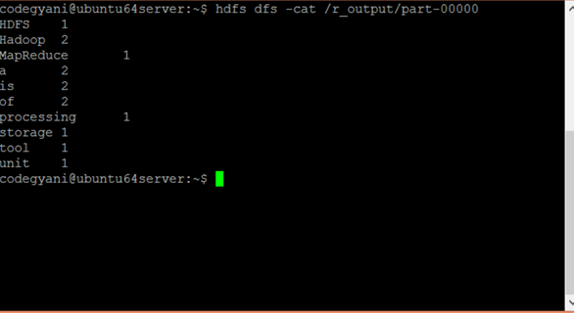

Result

Ex No.3 Implement an MR program that processes a weather dataset

Aim
To implement an MR program that processes a weather dataset .

Pre-lab Discussion
Inputs and Outputs (Java Perspective)
The MapReduce framework operates on <key, value> pairs, that is, the framework views the input to the job as a set of <key, value> pairs and produces a set of <key, value> pairs as the output of the job, conceivably of different types.

The key and the value classes should be in serialized manner by the framework and hence, need to implement the Writable interface. Additionally, the key classes have to implement the Writable-Comparable interface to facilitate sorting by the framework. Input and Output types of a MapReduce job − (Input) <k1, v1> → map → <k2, v2> → reduce → <k3, v3>(Output).

 | Input | Output
Map | <k1, v1> | list (<k2, v2>)
Reduce | <k2, list(v2)> | list (<k3, v3>)

Terminology
- PayLoad − Applications implement the Map and the Reduce functions, and form the core of the job.
- Mapper − Mapper maps the input key/value pairs to a set of intermediate key/value pair.
- NamedNode − Node that manages the Hadoop Distributed File System (HDFS).
- DataNode − Node where data is presented in advance before any processing takes place.
- MasterNode − Node where JobTracker runs and which accepts job requests from clients.
- SlaveNode − Node where Map and Reduce program runs.
- JobTracker − Schedules jobs and tracks the assign jobs to Task tracker.
- Task Tracker − Tracks the task and reports status to JobTracker.
- Job − A program is an execution of a Mapper and Reducer across a dataset.
- Task − An execution of a Mapper or a Reducer on a slice of data.
- Task Attempt − A particular instance of an attempt to execute a task on a SlaveNode.

Problem Statement:
Analyzing weather data of Fairbanks, Alaska to find cold and hot days using MapReduce Hadoop.

Step 1:

We can download the dataset from this Link, For various cities in different years. choose the year of your choice and select any one of the data text-file for analyzing. In my case, I have selected CRND0103-2020-AK_Fairbanks_11_NE.txt dataset for analysis of hot and cold days in Fairbanks,Alaska.
We can get information about data from README.txt file available on the NCEI website.

Step 2:
Below is the example of our dataset where column 6 and column 7 is showing Maximum and Minimum temperature, respectively.
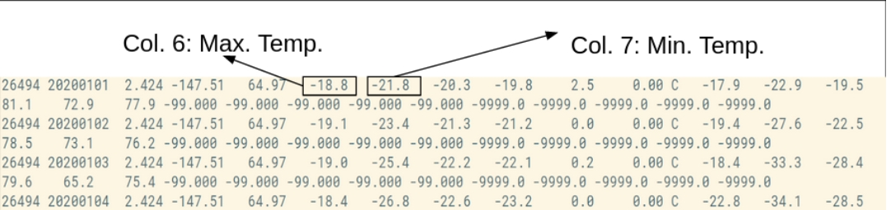

Step 3:

Make a project in Eclipse with below steps:
- First Open Eclipse -> then select File -> New -> Java Project ->Name it MyProject -> then
select use an execution environment -> choose JavaSE-1.8 then next -> Finish.
- In this Project Create Java class with name MyMaxMin -> then click Finish .
- Copy the below source code to this MyMaxMin java class

PROGRAM
import java.io.IOException;
import java.util.Iterator;
import org.apache.hadoop.fs.Path;
import org.apache.hadoop.io.LongWritable;
import org.apache.hadoop.io.Text;
import org.apache.hadoop.mapreduce.lib.input.FileInputFormat;
import org.apache.hadoop.mapreduce.lib.output.FileOutputFormat;
import org.apache.hadoop.mapreduce.lib.output.TextOutputFormat;
import org.apache.hadoop.mapreduce.lib.input.TextInputFormat;
import org.apache.hadoop.mapreduce.Job;
import org.apache.hadoop.mapreduce.Mapper;
import org.apache.hadoop.mapreduce.Reducer;
import org.apache.hadoop.conf.Configuration;
public class MyMaxMin {
// Mapper
/*MaxTemperatureMapper class is static
* and extends Mapper abstract class
* having four Hadoop generics type
* LongWritable, Text, Text, Text.
*/
public static class MaxTemperatureMapper extends
Mapper<LongWritable, Text, Text, Text> {
public static final int MISSING = 9999;
@Override
public void map(LongWritable arg0, Text Value, Context context)throws IOException,
InterruptedException {
// Convert the single row(Record) to
// String and store it in String
// variable name line
String line = Value.toString();
if (!(line.length() == 0)) {
// from character 6 to 14 we have
// the date in our dataset
String date = line.substring(6, 14);
// similarly we have taken the maximum
// temperature from 39 to 45 characters
float temp_Max = Float.parseFloat(line.substring(39, 45).trim());
// similarly we have taken the minimum
// temperature from 47 to 53 characters
float temp_Min = Float.parseFloat(line.substring(47, 53).trim());
// if maximum temperature is
// greater than 30, it is a hot day
if (temp_Max > 30.0) {
// Hot day
context.write(new Text("The Day is Hot Day :" + date),
new Text(String.valueOf(temp_Max)));
}
// if the minimum temperature is
// less than 15, it is a cold day
if (temp_Min < 15) {

// Cold day
context.write(new Text("The Day is Cold Day :" + date),
new Text(String.valueOf(temp_Min)));
}
}
}

}
// Reducer
public static class MaxTemperatureReducer extendsReducer<Text, Text, Text, Text> {
public void reduce(Text Key, Iterator<Text> Values, Context context) throws IOException, InterruptedException {
String temperature = Values.next().toString();
context.write(Key, new Text(temperature));
}
}
public static void main(String[] args) throws Exception {
Configuration conf = new Configuration();
// Initializing the job with the
// default configuration of the cluster
Job job = new Job(conf, "weather example");
// Assigning the driver class name
job.setJarByClass(MyMaxMin.class);
// Key type coming out of mapper
job.setMapOutputKeyClass(Text.class);
// value type coming out of mapper
job.setMapOutputValueClass(Text.class);
// Defining the mapper class name
job.setMapperClass(MaxTemperatureMapper.class);
// Defining the reducer class name
job.setReducerClass(MaxTemperatureReducer.class);
job.setInputFormatClass(TextInputFormat.class);
job.setOutputFormatClass(TextOutputFormat.class);
Path OutputPath = new Path(args[1]);
FileInputFormat.addInputPath(job, new Path(args[0]));
FileOutputFormat.setOutputPath(job, new Path(args[1]));
OutputPath.getFileSystem(conf).delete(OutputPath);
System.exit(job.waitForCompletion(true) ? 0 : 1);

}
}

Step 4:
- Now we need to add external jar for the packages that we have import. Download the jar package Hadoop Common and Hadoop MapReduce Core according to your Hadoop version.
- Now we add these external jars to our MyProject. Right Click on MyProject -> then select Build Path-> Click on Configure Build Path and select Add External jars…. and add jars from it’s download location then click -> Apply and Close.
- Now export the project as jar file. Right-click on MyProject choose Export.. and go to Java -> JAR file click -> Next and choose your export destination then click -> Next.
choose Main Class as MyMaxMin by clicking -> Browse and then click -> Finish -> Ok.

Step 5:
Start our Hadoop Daemons
start-dfs.sh
start-yarn.sh

Step 6:
Move your dataset to the Hadoop HDFS.
Syntax:
hdfs dfs -put /file_path /destination
In below command / shows the root directory of our HDFS.
hdfs dfs -put /home/dikshant/Downloads/CRND0103-2020-AK_Fairbanks_11_NE.txt /
Check the file sent to our HDFS.
hdfs dfs -ls /

Step 7:
Now Run your Jar File with below command and produce the output in MyOutput File.
Syntax:
hadoop jar /jar_file_location /dataset_location_in_HDFS /output-file_name
Command:
hadoop jar /home/dikshant/Documents/Project.jar /CRND0103-2020-AK_Fairbanks_11_NE.txt /MyOutput

Step 8:
Now Move to localhost:50070/, under utilities select Browse the file system and download part-r-00000 in /MyOutput directory to see result.

Step 9:
See the result in the Downloaded File.
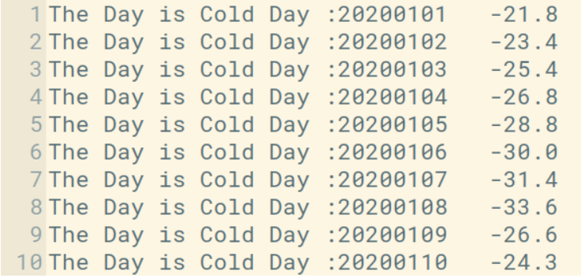

In the above image, you can see the top 10 results showing the cold days. The second column is a day in yyyy/mm/dd format. For Example, 20200101 means

year = 2020
month = 01
Date = 01

Result

